

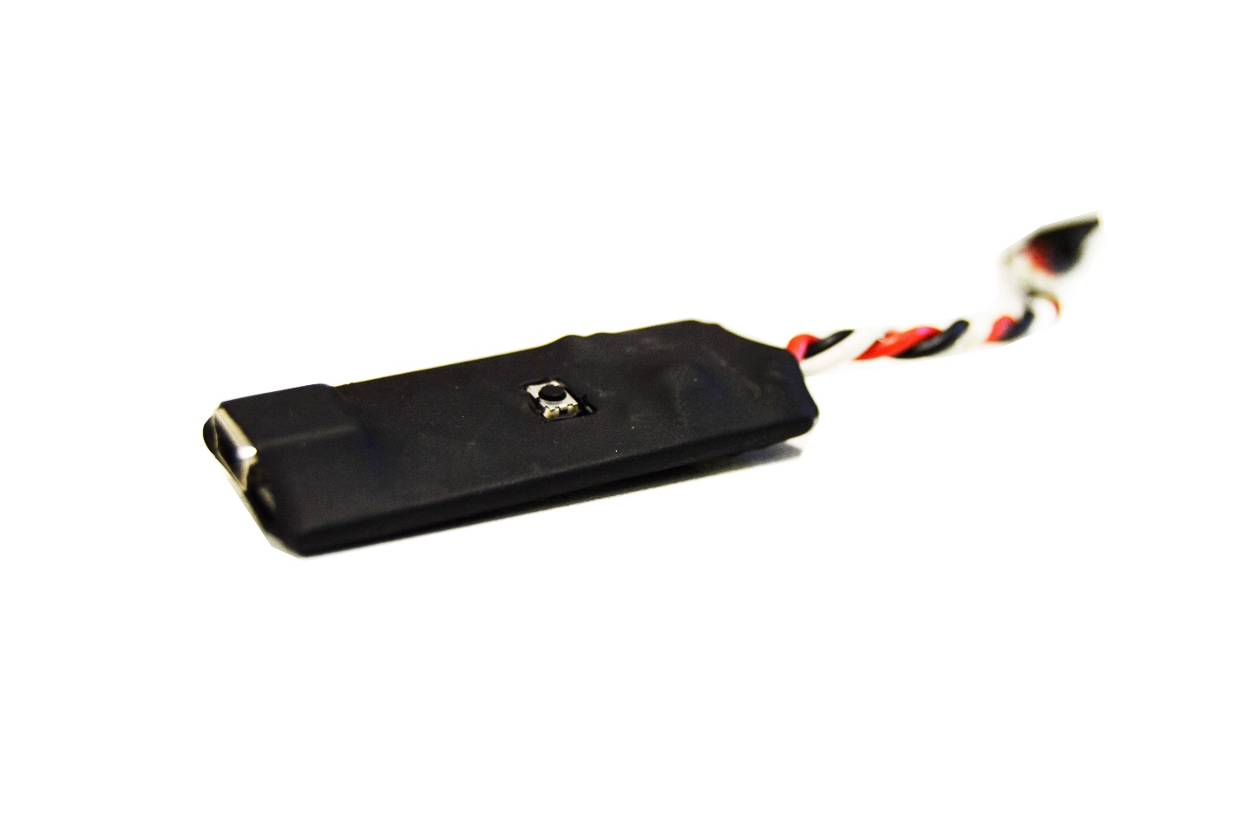

# **GETTING STARTED**

This is a telemetry relay board that sits between the **telemetry port** of your APM, Pixhawk or NAVIO+ module and the Smart Port of your FrSky receiver sending your flight controller telemetry to your Taranis radio.

# **PARTS**

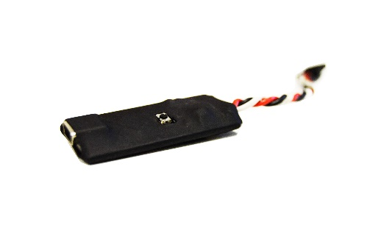

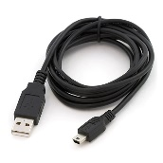

MavLink to FrSky Converter

Mini-USB cable (only if you have the USB version)

# **Assumptions**

* The Taranis radio transmitter is bound to its receiver which is connected to the "*MavLink to FrSky SmartPort Converter*” through its Smart Port;
* A "*MavLink to FrSky SmartPort Converter*" module is connected to an APM telemetry output, be it a USB or the native APM / Pixhawk telemetry port;
* The power to the "*MavLink to FrSky SmartPort Converter*" is supplied by the receiver’s Smart Port between 5 to 10V;
* The "*MavLink to FrSky SmartPort Converter*" has the firmware recommended by Airborne Projects;
* It is assumed you can connect to your APM module from the "Mission Planner" software on Windows, even though the steps are similar for QGroundControl available in every PC operating system;
* It is assumed you have a Mini-USB cable.

# **How to Enable Telemetry on Mission Planner**

1. Select the "Config/Tuning" tab;
2. Select "Full Parameter Tree";
3. For the secondary telemetry port configurations find the command node SR1\*. For information about what this parameters go to [ArduCopter’s SR1 official documentation](http://copter.ardupilot.com/wiki/configuration/arducopter-parameters/" \l "sr1__parameters);
4. In SR1 node set:
   1. SR1\_EXT\_STAT 10
   2. SR1\_EXTRA1 0
   3. SR1\_EXTRA2 10
   4. SR1\_EXTRA3 3
   5. SR1\_PARAMS 1
   6. SR1\_POSITION 1
   7. SR1\_RAW\_CTRL 0
   8. SR1\_RAW\_SENS 10
   9. SR1\_RC\_CHAN 0
5. Find the command node SERIAL1 and set:
   1. SERIAL1\_BAUD 57
   2. SERIAL1\_PROTOCOL 1
6. In the write side of the window find and click in "Write Params".

\* Can be SR1 or SRa where “a” is the number of the telemetry port you want to connect the converter to. The procedure above is analogous for other Serial ports.

# **Loading the Lua telemetry files to the Taranis remote**

1. Ensure you have your Taranis transmitter turned off;
2. Enter bootloader mode by sliding both horizontal trims, each under the main sticks, to the center of the remote and then turn on the radio;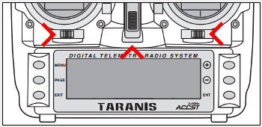
3. A Taranis bootloader screen should show. If you still hear the normal greeting message you have not entered the Bootloader Screen, thus you should repeat the previous steps in this section;
4. Without selecting any menu connect the USB mini to the back of your Taranis and the USB to your computer. The text "USB Connected" will be displayed. If you turn on the USB with the Radio off it will not be able to turn on until you disconnect it;
5. In your computer there should be a notification that 2 Removable Drives have been added to your computer. One says "Taranis" and the other has a non-descriptive. You should choose the one with the non-descriptive name. One way to spot it is that the one with .BIN files is the wrong drive;
6. In the root of the correct drive there should be several folders but you should find one called "Scripts". Don't exit this directory because you will past files to it.
7. Inside the "Scripts" directory you can either already have a customized folder name or if you never changed the contents of "Scripts" folder, the folder should be named "Model01". Go inside it;
8. In the product page there is a link to download a zip file called FrSkyTelemetry.zip. Unpack to your desired location. This file contains the firmware source code as well as the Lua telemetry script;
9. In the directory where you unpacked it find the Lua directory and copy both Telem1.lua and Telem2.lua to the folder mentioned in step 7;
10. Safely remove both drives and turn on your Radio and remove the USB cable. After turning it on, pressing longer in the "Page" button of you radio will take you to the telemetry pages, assuming your Hardware is correctly configured.

# **HUD Description**

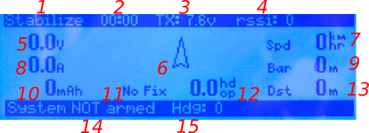

1. APM current Flight Mode
2. Taranis Timer
3. Taranis Battery Voltage
4. RSSI / radio signal quality
5. Airframe battery voltage (should be calibrated through Mission Planner for this to be meaningful)
6. Relative Heading Arrow. When system is not armed points measured heading. When armed, displays the heading relative to the arming orientation
7. GPS speed. Only shows when GPS is acquired or enabled
8. Measured battery current draw (similar to voltage meter must be calibrated);
9. Barometric Altitude (altitude measured by barometric sensor)
10. Integrated power over time (be sure you have both voltage and current calibrated before relying on this)
11. GPS status or number of satellites available
12. HDOP (horizontal dilution of precision). A measure of the geometric quality of a GPS satellite configuration in the sky. The lower the better
13. Distance from first GPS position received by the Taranis
14. Arming status emitted by APM
15. Numeric representation of the arrow angle

# **CONVERTER DESCRIPTION**

**USB/NAVIO+ Version**

**UART/Telemetry Port Version**

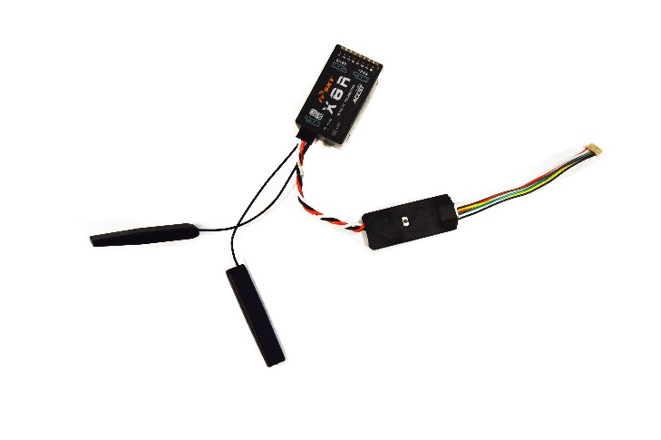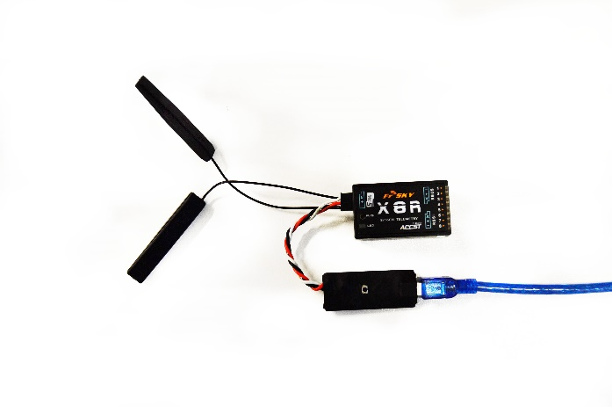

**1**

**2**

**2**

**1**

**3**

**4**

1. MavLink to FrSky SmartPort Converter
2. FrSky receiver with Smart Port (telemetry compatible)
3. UART/Telemetry cable (only on UART version)
4. USB cable (only on USB version)

# **SPECIFICATIONS**

* Translation of Mavlink messages to FrSky Smart Port format
* User friendly telemetry LUA script that detects APM arming to provide relative heading regarding arming orientation, direct from the APM IMU
* Cheaper alternative to Teensy
* Lower Power Consumption (20mA)
* Input voltage range: 5V-10V (powered by receiver SMART Port)
* Heat-shrinked wrapping to afford debris protection without compromising weight

# **SPECIFICATIONS**

For more information about the loaded firmware source files and scripts, visit <https://github.com/ptsneves/FrSkyTelemetry>.

For customer support, contact us at [info@airborneprojects.com](mailto:info@airborneprojects.com).